ComicsWorld

Vision Document

Version 1.3

Revision History

| **Date** | **Version** | **Description** | **Author** |
| --- | --- | --- | --- |
| 20/06/2023 | 1.0 | Write part 1 and 2 | Nguyễn Thuận Phát |
| 23/06/2023 | 1.1 | Write part 3, 3.1, 3.2, 3.3 | Ngô Quốc Quý |
| 28/06/2023 | 1.2 | Write part 5 and 6 | Nguyễn Thuận Phát |
| 30/6/2023 | 1.3 | write part 3.4, 3.5 and part 4 | Ngô Quốc Quý |

Table of Contents

**1. Introduction 4**

1.1 References 4

**2. Positioning 4**

2.1 Problem Statement 4

2.2 Product Position Statement 4

**3. Stakeholder and User Descriptions 4**

3.1 Stakeholder Summary 4

3.2 User Summary 5

3.3 User Environment 5

3.4 Summary of Key Stakeholder or User Needs 6

3.5 Alternatives and Competition 6

**4. Product Overview 7**

4.1 Product Perspective 7

4.2 Assumptions and Dependencies 8

**5. Product Features 8**

**6. Non-Functional Requirements 9**

Vision (Small Project)

# Introduction

The purpose of this document is to collect, analyze, and define high-level needs and features of the ComicsWorld. It focuses on the capabilities needed by the stakeholders and the target users, and **why** these needs exist. The details of how the ComicsWorld fulfills these needs are detailed in the use-case and supplementary specifications.

## References

1. Learning materials, moodle, HCMUS

# Positioning

## Problem Statement

| The problem of | sharing and reading copyright-verified comics |
| --- | --- |
| affects | amateur authors who want to share their comics and everyone who wants to read comics |
| the impact of which is | authors who are not famous or amateur and readers who want to discover new comics |
| a successful solution would be | authors can share their comics and become well-known. Readers can read comics according to their interests |

## 

## Product Position Statement

| For | amateur authors and readers |
| --- | --- |
| Who | share and read comics |
| The ComicsWorld | is a website |
| That | allows authors to post their comics and and readers to read posted comics |
| Unlike | online comic websites that infringe copyright |
| Our product | allows readers to read copyright-verified comics and helps amateur authors become well-known |

# Stakeholder and User Descriptions

This section describes the users of The Comics World System. There are 3 types of users of this system; the Readers, the Administrators, the Uploader.

## Stakeholder Summary

| **Name** | **Description** | **Responsibilities** |
| --- | --- | --- |
| IT development team | Developing the system. | Responsible for developing and maintaining the system. Ensure that the users can be enjoyable when using this system. |
| Supervisor-advisor (Lecturer: NTMTuyen, HTThanh) | Giving advices in process to develop the system | A mentor/sub-advisor who helps the IT development team have the knowledge about the process of developing a software product. |
| Administrator | Site management | Ensure that the data, information, report about the website will be clear, the experiences of users will be good. |
| Reader | Reading | Ensure that the system will meet the needs of readers. |
| Uploader | Uploading the comic | Ensure that the system will provide them a good way to upload the comics. |

## User Summary

| **Name** | **Description** | **Responsibilities** | **Stakeholder** |
| --- | --- | --- | --- |
| Administrator | Site management | Administrator has a role of managing the accounts and database of a website,providing accounts for uploaders. and receiving the information from users (readers, uploaders), and indirecting the reports for the IT development team. | self-presentation |
| Reader | Reading the comics | Readers can register to sign in and follow the comics, report if the comic’s chapter has any problem, rate them, and comment. | self-presentation |
| Uploader | Uploading the comics | The uploaders can be provided an account to upload the comics, receive the report from the readers and direct it to the admin. | self-presentation |

## User Environment

The community of users who love Comics World is a large community with a variety of ages, characteristics, hobbies that the system can service.

The users are people who have a liking for comics, and have a little knowledge about comics. The uploaders will upload new chapters of any comics for a limited time (often 3 - 4 days for a chapter), the readers have a flexible time to read comics, and the administrators have to check, manage the site for 5 - 6 hours per day.

The users have their own smart devices like laptops, smartphones,... The ability to use the service of the website is flexible (anytime, anywhere).

The initial release of the Comics World will be limited for young people who love reading comics, and have an interest in the work about comics in VietNam. As a result, the Comics World will be designed to be expandable for the community in various countries in the near future.

## Summary of Key Stakeholder or User Needs

| **Needs** | **Priority** | **Concerns** | **Current Solution** | | **Proposed Solutions** |
| --- | --- | --- | --- | --- | --- |
| Visibility and reach | Low | Platform with a large and engaged reader base to gain exposure and expand their audience | None | | Providing a comprehensive genre system, allowing users to categorize their webcomics accurately. Facilitating active engagement and interaction among uploaders and readers through features like forums, comment sections, and the ability to share and recommend webcomics. |
| Platform and tool easy to use | High | Offering easy-to-use tools for uploading, organizing and showcasing the comics | The platform provides users with the ability to use the services like: upload and organize, and present the comics in a visually appealing format. | | Optimizing for mobile viewing, ensuring a seamless and enjoyable reading experience on smartphones and tablets, prioritizing ease of use and offering a simple and intuitive interface for uploaders to upload and manage their comic pages effectively. |
| Diverse content | Medium | Offering a wide range of genres, styles, and storytelling formats to suit the user’s preferences. | None | | Collecting data about the stories from various source |
| User friendly experience | High | Intuitive navigation, convenient bookmarking, and personalized recommendations to enhance the reading experience. | None | | Providing many functions friendly for the readers like large menu icons with intuitive categories for communication |

## Alternatives and Competition

| **Competitors:** | NetTruyen  MangaDex  Comic Fury  Hiveworks  Wattpad | |
| --- | --- | --- |
| **Alternatives:** | Tiny community | Easy to discuss with each other, admin can also easily to manage the user, to solve the problems when having reports |
| Friendly environment, nice interface | A nice interface for user, the color of website is soft, paying attention to the user’s feelings |

# Product Overview

This section provides a high level view of Comic World system capabilities, interfaces to catalog database system, and system configurations. This section usually consists of two subsections.

## Product Perspective

The Comics World web application is an innovative product which replaces other ones with user-friendly interfaces that appeal to users.

This web is created for those who love comics, maybe work or relax with it

The product is completely free for everyone although the quality is still ensured. The data is contained on the existing catalog system and toward ComicsWorld system to interact with users.

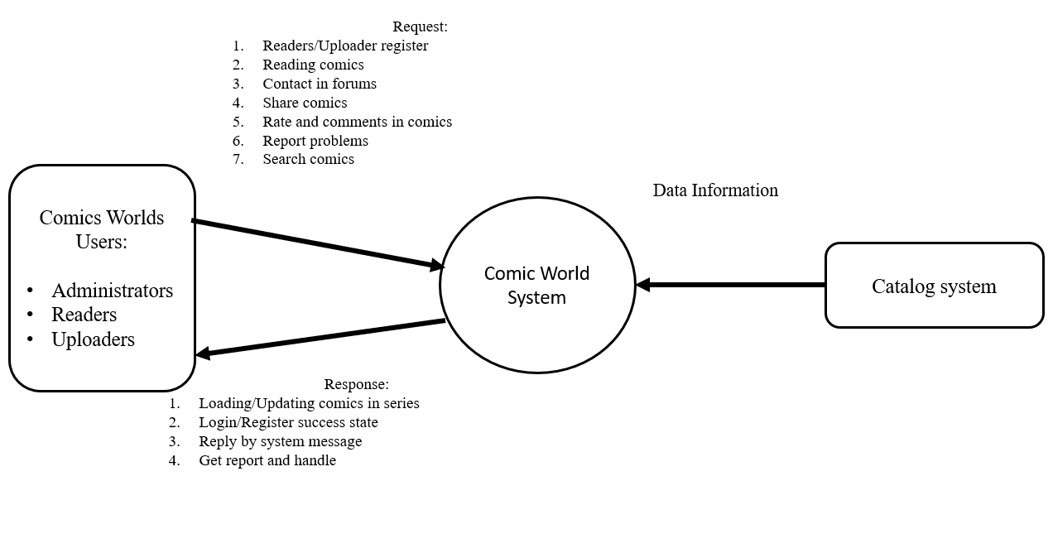

## Assumptions and Dependencies

The product will be used on a web browser system.

• If there are changes in the development process, the vision document needs to be updated with this information.

• This product is expected to be used in the next 5 to 6 years and frequently updated during this period.

# Product Features

This section describes and defines the features of the ComicsWorld website. Features are the high-level capabilities of the website that are necessary to deliver benefits to the users.

1. **Login**

Visitors can register an account to become members of the website. To be able to perform actions such as commenting, following, rating... visitors must login first. The uploader accounts are regular reader accounts that received the right to upload comics by the web managers. The web manager accounts are the most powerful accounts, they are used to manage the website.

1. **Reading comic**

There are a lot of comics displayed on the website body. They are grouped into several sections . Readers choose the comics they want to read and then click on their images to read them. Comics on this website are divided into chapters which make it easier for readers to read. The comic page will be displayed as images.

1. **Follow comic series**

Users can click the follow button in order to get notification about the new chapter as soon as possible. Uploaders can see the list of readers who follow their comics.

1. **Express feelings**

Readers can comment on the comic chapter to show their feelings about it. One’s comment may be reported by another person if it is inappropriate. Only members can comment on a comic chapter.

This website also allows readers to rate a comic on a scale of 1 to 5 stars to show how good it is. Each comic can only be rated once.

1. **Report problems**

Readers can report a comic if it has some problem such as copyright, faulty images,...etc. Web manager and comic uploader receive the reports from readers and have suitable solution

1. **Search for comics**

Users can search for a comic by its name using the search bar on the website header. Comics are divided into different genres to help users in searching.

1. **Create and upload comics**

Uploaders can create the new comic on the website(Avatar/poster, name of comic, and description are required) and then they will be able to upload their products by each chapter. In order to do this, their accounts must be given a right by the admin.

1. **Remove comics or comments**

Web managers remove a comic from the website when it has a problem with copyright. The web manager can also delete a comment if it contains bad words.

1. **Comic management**

Uploaders manage their uploaded comics including following the view and receiving reports from the viewers. Uploader assumes full responsibility for what they have posted. If a problem(copyright, image quality,...) occurs, they must have an appropriate solution. Web managers can also see the number of views of a comic, reports from members. The difference is that uploaders can only track the views and reports of their uploaded comics while the web manager can see all of the comics on the website.

1. **Authority Management**

Web managers can give/revoke the right to upload comics to uploaders. First, the uploaders create their accounts just like the regular members and contact the web managers(by email given on the website). After verifying their profile, the web manager gives their accounts the right to upload comics..

1. **Punishment(banning)**

Web managers can ban members if they have inappropriate comments. The banned members cannot perform such actions as rating, commenting,...They can also ban uploaders if they violate the rules of the website.

# Non-Functional Requirements

1. **Copyright requirements**

When authors post their comics to the website, the website gets their agreement about copyright. Authors must make sure that the posted comics are their own product.

1. **Responsive requirements**

Readers can use any device to read comics, such as smartphones, laptops, PCs,...etc. The website will change its UI to fit user device